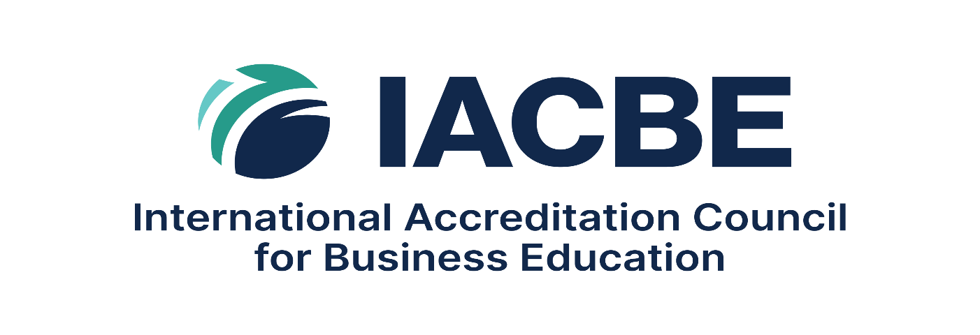
International Accreditation Council for Business Education
Certificate Program Self-Study Template
11960 Quivira Road, Suite 300
Overland Park, KS 66213

- MISSION AND PURPOSE

IACBE Expectation
The business unit has a clearly defined mission and Statement of Purpose that are consistent with those of the institution and that explicitly encompass business education.

Required Responses/Documentation

- Provide the institution’s mission statement.

- Provide the mission of the business unit.

- Provide the Statement of Purpose for each certificate program.

- Explain how the certificate programs seeking accreditation are aligned with the mission of the business unit.

- CURRICULUM DEVELOPMENT, EVALUATION

IACBE Expectation
Excellence in business education is demonstrated by business programs that prepare students to be competent business professionals. This includes processes for program development and design, curricular content and learning opportunities, and curriculum review, renewal, and improvement.

Required Responses/Documentation

- Demonstrate where the curricular and completion requirements for each certificate program seeking accreditation are made available to the public.

- Describe the process specific to the development and renewal of certificate program curriculum.

- Explain the justification for determining which courses are chosen for inclusion in a certificate program.

- Explain how each program aligns with current industry standards.

- How does the business unit ensure that certificate programs remain aligned with current industry needs and employer expectations? Provide evidence.

- Describe the pedagogical approaches you use to prepare students for success in the relevant industry field.

- QUALITY ASSESSMENT AND ADVANCEMENT

IACBE Expectation
The business unit must have an established process for outcomes assessment that supports continuous improvement. To demonstrate its oversight and assessment of student learning and the business unit’s operational performance levels, the business unit must develop and implement a Certificate Outcomes Assessment Plan (OAP) that serves as the roadmap for regular and ongoing outcomes evaluation and continual improvement.

Required Responses/Documentation

- Using the OAP for Certificate programs, provide the forward-looking IACBE Outcomes Assessment Plan for each certificate program seeking accreditation. Use the Certificate OAP Template (instructions included).

- ADMISSIONS

IACBE Expectation
The IACBE expects that the business unit has established policies and procedures for the admission of students to its business programs that are readily available and transparent to the general public and applied in a consistent and equitable manner. The standards for acceptance to business programs must be appropriate to the type and curriculum level of each program and designed to ensure that students have a reasonable chance to succeed.

Required Responses/Documentation

- Provide a copy of the admission policies relevant to each certificate program seeking accreditation.

- Provide the URL to where these policies are made available to the general public.

- FACULTY

IACBE Expectation
IACBE expects that business education programs are delivered by highly qualified faculty who hold an appropriate combination of degrees and/or professional experience relevant to their subject areas of teaching, remain current in their fields of teaching, and participate in ongoing professional development activities.

Required Responses/Documentation

- Provide a completed Certificate Faculty Table (upload in the Appendices).
  - Provide a current Curriculum Vitae for each faculty member teaching business-related course(s) in a certificate program seeking accreditation (upload in the Appendices).

- Describe the business unit’s process for hiring faculty to teach in a certificate program. Be sure to address the manner in which a faculty member’s qualifications are competent in the subject area to be taught.

- Explain the ongoing process for ensuring that faculty remain current in the subject areas they teach in the certificate program(s).

- STUDENT ACHIEVEMENT AND ACCOUNTABILITY

IACBE Expectation
The IACBE expects that the business unit has established academic policies and procedures for supporting students in preparing for achieving their career goals. Additionally, the IACBE requires Certificate programs to annually calculate measures of student achievement and make this information readily available to the general public.

Required Responses/Documentation

- Provide the requirements for academic progression and completion of certificate programs.

- Provide the Public Disclosure of Student Achievement for Certificate programs.

- (reaffirmations only) Provide the URL to where on the institution’s website the PDSA for Certificate programs is posted. *

- For each certificate program, provide a sampling list of potential job positions and places of employment applicable to certificate program graduates, including positions secured by past graduates.

* For business units seeking First-Time Accreditation for certificate programs, there will not be a Public Disclosure of Student Achievement posted at the time of the Self-Study: it will not be a requirement until after programs achieve IACBE accreditation. Within 30 days of notification of approval of program accreditation, the Public Disclosure of Student Achievement must be posted to the business unit’s website and a WebPath Notification Form must be submitted. More detailed information will be provided in the Board of Commissioner Decision letter.

- RESOURCES & INNOVATION

IACBE Expectation
The IACBE expects that the business unit’s resources are sufficient to support, sustain, and improve all aspects of its activities.

Additionally, The IACBE expects business units to adapt and respond to the challenges of preparing students to be competent business professionals in today’s dynamic and increasingly complex business environments through innovation and creativity.

The IACBE recognizes that what constitutes innovation is unique to each business unit, and as such expects involvement of faculty and external communities of interest in supporting ongoing modernization and improvements in curricula and instructional delivery.

Required Responses/Documentation

- Describe the learning and instructional resources specific to delivery of certificate programs seeking accreditation.

- Describe how the institution is innovative in its approach to the delivery of certificate program education. Provide examples and explain how they have impacted the student experience.

