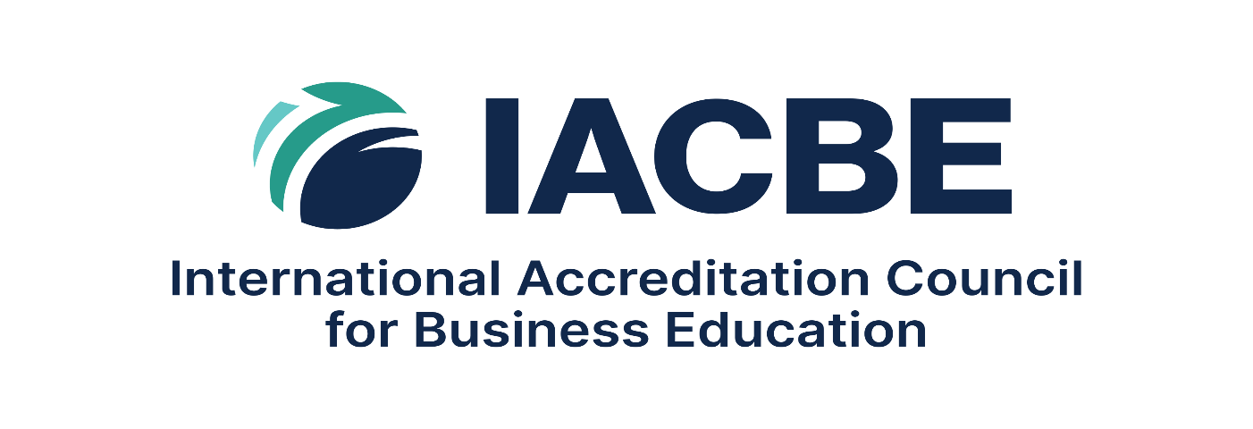
International Accreditation Council for Business Education
Certificate Program Accreditation
11960 Quivira Road, Suite 300
Overland Park, KS 66213


Program Overview

Certificate Accreditation Program

“Certificate” refers to any credit-bearing, non-degree program of study.

IACBE accreditation of certificate programs provides a means for an institution to enhance its development, assessment, and ongoing quality improvement of its certificate program offerings in the areas of business. The intent of these programs should be to provide students with practical knowledge and skills that support employment in a related field, or to enhance learning relevant to the current marketplace. Accreditation of certificate programs can be beneficial for Members to meet or exceed third party and governmental requirements. For example, for those institutions in the United States, IACBE accreditation will foster assessment of these programs that will better ensure alignment with various government agencies, such as the U.S. Department of Education Gainful Employment requirements by requiring demonstration of student benefit.

IACBE is recognized as a programmatic accrediting agency by the Council for Higher Education Accreditation (CHEA). Recognition by CHEA conveys that the accrediting organization meets the CHEA Recognition Standards and is available to accrediting organizations that accredit institutions or programs which grant degrees at the associate degree level or higher. Because programs eligible for this accreditation process are not at the associate degree level or higher, the IACBE accreditation of certificate programs is not included in the IACBE Scope of Accreditation as approved by the Council for Higher Education Accreditation (CHEA).

Program Eligibility Requirements
To be eligible for IACBE accreditation, a certificate program must award a minimum of 12 post-secondary education semester credits, or equivalent credit hours. 50% of the total credits must be in an area of business ¹. The credential awarded is separate and irrespective of any degree program. There must be a process for ongoing curricular assessment and improvement that ensures relevance to the current business environment, including regular analysis of learning and achievement outcomes. Certificate programs must be in good standing with all institutional or governmental oversight requirements.

IACBE Expectations
Excellence in business education is multidimensional and may be interpreted in diverse ways depending on the educational, historical, cultural, legal/regulatory, and organizational environments in which the business unit operates. It is our expectation that the business unit engages in ethical and transparent practices that are driven by and toward achievement of its mission.

To achieve and maintain IACBE accreditation, expectations for each certificate program are to:
- Ensure that certificate programs remain aligned with current industry needs, employer expectations, and required industry standards.
- Monitor and evaluate student achievement measures, including enrollment and employment.
- Provide evidence of transparent disclosure to the public of student achievement measures including enrollment and employment.
- Have a Statement of Purpose.
- Demonstrate that an established and practiced process is in place to evaluate achievement toward the Statement of Purpose.
- Be taught by qualified faculty who engage in ongoing professional development in the subject area taught within the certificate program.
- Include high impact practices.
- Admit students who have the foundational knowledge to be successful.

General Process
The process for IACBE accreditation of certificate programs will be similar to that of accreditation degree-level programs. The first time an institution seeks accreditation for a certificate program(s), the accreditation process will include a Board of Commissioner review. Once an institution has received Board of Commissioner approval for certificate program(s), it may seek accreditation for additional certificate programs. The review of added certificate programs will be conducted at the IACBE staff level. The grant of certificate program accreditation will correspond to the timeline of the institution’s existing period of accreditation of its IACBE-accredited degree-level programs. For reaffirmation of certificate program accreditation, a separate Self-Study add-on specific to accreditation of certificate programs will be submitted. Review and reaffirmation of certificate program accreditation will coincide with all activities, timelines, and procedures for reaffirmation of accreditation of degree-level programs.

Reporting Requirements
Annual reporting of student achievement is required. This information will be reported to the IABCE using the Public Disclosure of Student Achievement for Certificate programs and posted on the institution’s website.

Seeking Certificate program Accreditation for the First-Time
- Institution notifies the IACBE of its intent to seek accreditation of certificate program(s) by completing an Application for New Program Accreditation and paying the fee (to be invoiced after receipt of the application).
- IACBE liaison will work with the institution to develop a timeline.
- Institution submits a draft Certificate program Self-Study.
- IACBE Liaison conducts a technical review with the business unit.
- Institution submits final Certificate program Self-Study.
- Board of Commissioners reviews certificate program(s) and makes an accreditation decision.
- Upon Board of Commissioner approval, the programs will be granted Specialized Certificate Accreditation.

Seeking Reaffirmation of Certificate program Accreditation
Reaffirmation of Certificate program Accreditation will follow the same policies and procedures as reaffirmation of accreditation, with the addition of separate Certificate program Self-Study and corresponding required documentation. Refer to the IACBE Accreditation Process Manual.

IACBE Certificate Program Self-Study Manual

- MISSION AND PURPOSE

IACBE Expectation
The business unit has a clearly defined mission and Statement of Purpose that are consistent with those of the institution and that explicitly encompass business education.

Required Responses/Documentation

- Provide the institution’s mission statement.
- Provide the mission of the business unit.
- Provide the Statement of Purpose for each certificate program.

The Statement of Purpose (SOP) is a tightly focused statement that describes the goal and intended outcomes for student achievement upon completion of the program. Upon completion of the program, how will the student have benefited? The SOP must incorporate measurable components.

- Explain how the certificate programs seeking accreditation are aligned with the mission of the business unit.

- CURRICULUM DEVELOPMENT, EVALUATION

IACBE Expectation
Excellence in business education is demonstrated by business programs that prepare students to be competent business professionals. This includes processes for program development and design, curricular content and learning opportunities, and curriculum review, renewal, and improvement.

Required Responses/Documentation

- Demonstrate where the curricular and completion requirements for each certificate program seeking accreditation are made available to the public.
- Describe the process specific to the development and renewal of certificate program curriculum.
- Explain the justification for determining which courses are chosen for inclusion in a certificate program.
- Explain how each program aligns with current industry standards.

How does this program align with the industry it is meant to serve - or with professional organization (e.g., Project Management Institute; American Marketing Association; Banking, Insurance and Finance Federations; trade associations, etc.)

Agencies such as the Department of Labor and Chamber of Commerce, may provide statistics that provide skills needed for specific industry

- How does the business unit ensure that certificate programs remain aligned with current industry needs and employer expectations? Provide evidence.

Examples of evidence could be history of endorsements/evaluations from employers, surveys of employers, advisory board meeting minutes.

- Describe the pedagogical approaches you use to prepare students for success in the relevant industry field.
- Explain the process used to ensure that students will be successful in the program.

- QUALITY ASSESSMENT AND ADVANCEMENT

IACBE Expectation
The business unit must have an established process for outcomes assessment that supports continuous improvement. To demonstrate its oversight and assessment of student learning and the business unit’s operational performance levels, the business unit must develop a Certificate Outcomes Assessment Plan (OAP) that serves as the roadmap for regular and ongoing outcomes evaluation and continual improvement.

Required Responses/Documentation

The following are specific to the Certificate program Outcomes Assessment Plan for each Certificate program:
- Statement of Purpose
- At least two assessment measures, with a minimum of one Direct assessment measure, which evaluate progress toward achievement of the Statement of Purpose.

- Using the OAP for Certificate programs, provide the forward-looking IACBE Outcomes Assessment Plan for each certificate program seeking accreditation.

- ADMISSIONS

IACBE Expectation
The IACBE expects that the business unit has established policies and procedures for the admission of students to its business programs that are readily available and transparent to the general public and applied in a consistent and equitable manner. The standards for acceptance to business programs must be appropriate to the type and curriculum level of each program and designed to ensure that students have a reasonable chance to succeed.

Required Responses/Documentation

- Provide a copy of the admission policies relevant to each certificate program seeking accreditation.
- Provide the URL to where these policies are made available to the general public.

- FACULTY

IACBE Expectation
IACBE expects that business education programs are delivered by highly qualified faculty who hold an appropriate combination of degrees and/or professional experience relevant to their subject areas of teaching, remain current in their fields of teaching, and participate in ongoing professional development activities.

Required Responses/Documentation

- Provide a completed Certificate Faculty Table.
  - Provide a current Curriculum Vitae for each faculty member teaching business-related course(s) in a certificate program seeking accreditation.
- Describe the business unit’s process for hiring faculty to teach in a certificate program. Be sure to address the manner in which a faculty member’s qualifications are competent in the subject area they will be teaching.
- Explain the ongoing process for ensuring that faculty remain current in the subject areas they teach in the certificate program(s).

Some examples of supporting documentation: certificates of completion of industry workshops, proof of continuing education in subject area.

- STUDENT ACHIEVEMENT AND ACCOUNTABILITY

IACBE Expectation
The IACBE expects that the business unit has established academic policies and procedures for supporting students in preparing for achieving their career goals. Additionally, the IACBE requires Certificate programs to annually calculate measures of student achievement and make this information readily available to the general public.

Required Responses/Documentation

- Provide the requirements for academic progression and completion of certificate programs.
- (reaffirmations only) Provide the Public Disclosure of Student Achievement for Certificate programs. *
- (reaffirmations only) Provide the URL to where on the institution’s website the PDSA for Certificate programs is posted. *
- For each certificate program, provide a sampling list of potential job positions and places of employment applicable to certificate program graduates, including positions secured by past graduates.

* For business units seeking First-Time Accreditation for certificate programs, there will not be a Public Disclosure of Student Achievement posted at the time of the Self-Study: it will not be a requirement until after programs achieve IACBE accreditation. Within 30 days of notification of approval of the certificate program accreditation, the Public Disclosure of Student Achievement must be posted to the business unit’s website and a WebPath Notification Form must be submitted. More detailed information will be provided in the Board of Commissioner Decision letter.

- RESOURCES & INNOVATION

IACBE Expectation
The IACBE expects that the business unit’s resources are sufficient to support, sustain, and improve all aspects of its activities.

Additionally, The IACBE expects business units to adapt and respond to the challenges of preparing students to be competent business professionals in today’s dynamic and increasingly complex business environments through innovation and creativity.

The IACBE recognizes that what constitutes innovation is unique to each business unit, and as such expects involvement of faculty and external communities of interest in supporting ongoing modernization and improvements in curricula and instructional delivery.

Required Responses/Documentation

- Describe the learning and instructional resources specific to delivery of certificate programs seeking accreditation.
- Describe how the institution is innovative in its approach to the delivery of certificate program education. Provide examples and explain how they have impacted the student experience.

business administration, accounting, entrepreneurship, finance, human resources, information technology, international business, leadership, logistics, management, marketing, business strategy, economics, business law, ethics, communication, analytics, and quantitative methods

