CONFERENCE AGENDA

Thursday | October 26, 2023

*Optional Training Activities In-Person ONLY*

12:00 p.m. – 4:00 p.m. IACBE Outcomes Assessment Training (OAP) (in person only)

ADDITIONAL $250 fee: Includes break refreshments.

7:00 p.m. – 9:00 p.m. Optional Dinner: The Mooring Restaurant

1 Sayers Wharf, Newport, RI 02840. Attendees pay for own meals.

Friday | October 27, 2023

*(zoom Link to be provided to student teams and guest speakers)*

8:00 – 8:45 a.m. Registration and Breakfast

8:45 – 9:00 a.m. Welcome to the Conference & Region 1 Reporting

9:00 – 9:50 a.m. Dr. Pat Hafford, IACBE, President

*9:00 – 12:00 a.m. Student Case Competition Preparation – Students Only*

9:50- 10:00 a.m. 10 min break

10:00 - 10:50 a.m. Session 2- TBD

10:50 - 11:00 a.m. 10 min break

11:00 – 12:00 p.m. Speed Presentations

12:00 – 1:00 p.m. Luncheon

1:00 – 1:50 p.m. Session 3-TBD

2:00 – 2:50 p.m. Group Discussion

1:00 – 3:00 p.m. *Student Case Competition Presentations – Students Only*

Friday |October 6, 2023

***Optional Zoom: 2526.us/reg23-fri***

8:00 - 8:45 a.m. Registration and Breakfast

Location: Franklin University, Fisher Hall, Room 168

8:45 – 9:20 a.m. Regional Business Meetings

***9:20 - 9:30 a.m. 10 min break: Reconvene from business meetings***

9:30 – 9:50 a.m. IACBE Update from National

***9:50 - 10:00 a.m. 10 min break***

10:00 - 10:50 a.m. Session 7

***10:50 - 11:00 a.m. 10 min break***

11:00 - 11:50 a.m. Session 8

11:50 a.m. – 12:00 p.m. Closing Remarks

*Regional Presidents*

12:00 p.m. Box lunches are available for the face-to-face participants that need

to travel or join others for an informal lunch before you leave

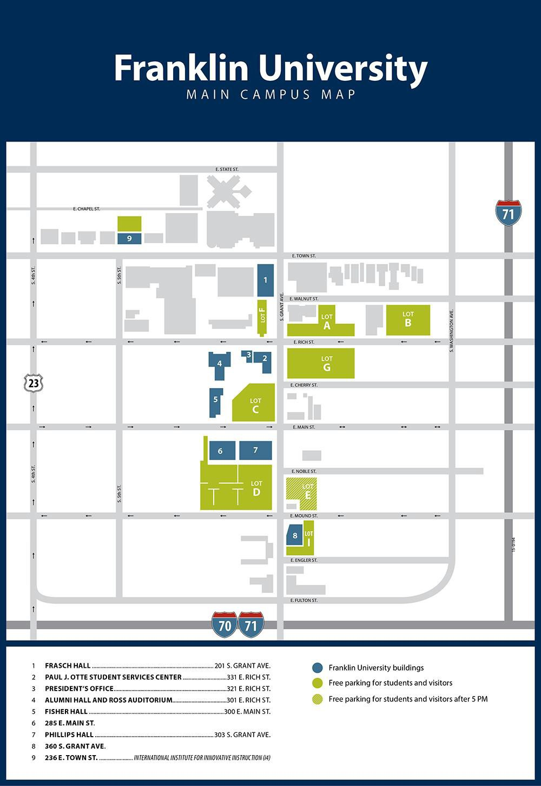

Holiday Inn Capitol

We have move to Fisher Hall 168, which is located

behind

Free parking in Lot C. The Clocktower is located in this lot atthe corner of Main Street and Grant Ave.