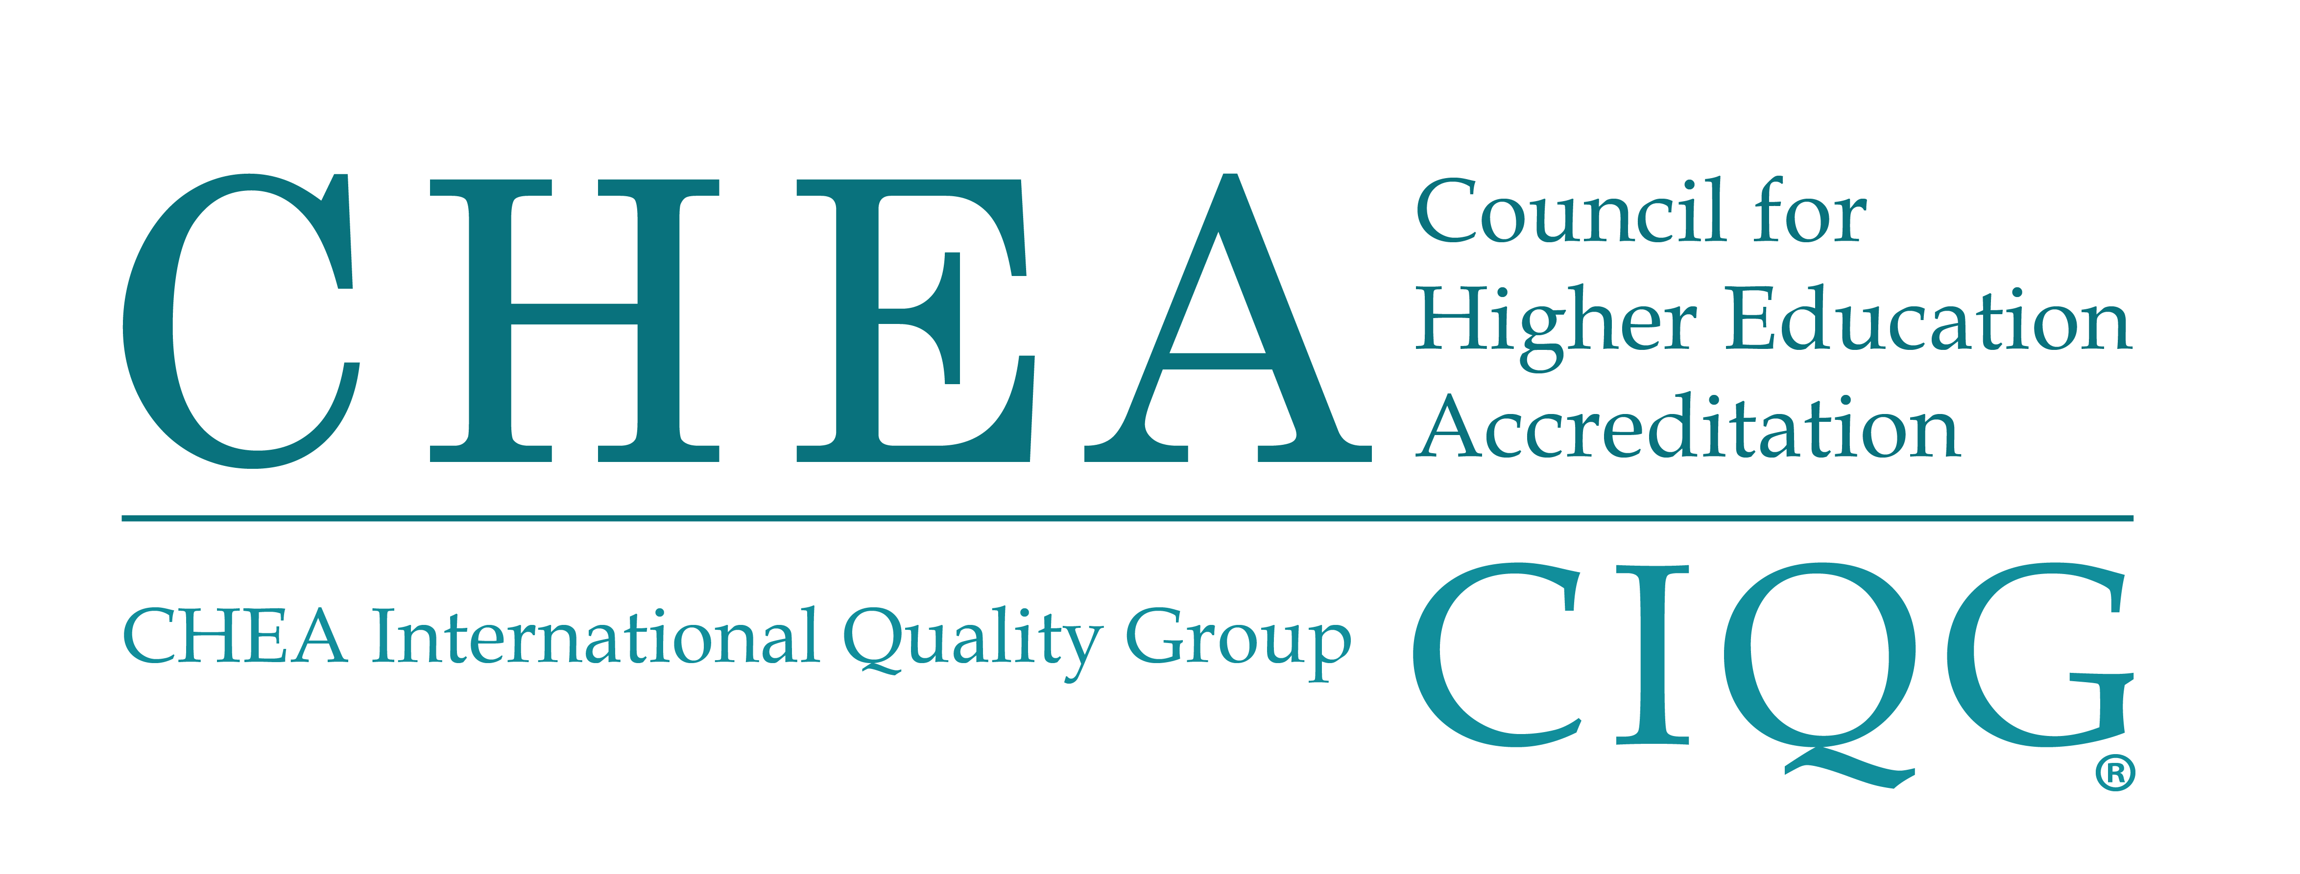

COUNCIL FOR HIGHER EDUCATION ACCREDITATION

PUBLIC STATEMENT OF CHEA RECOGNITION

May 3, 2021

Statement to be used by Accrediting Organizations for Recognition

At its meeting on May 3, 2021, the Council for Higher Education Accreditation (CHEA) Board of Directors reviewed the recommendation of the CHEA Committee on Recognition regarding the recognition application submitted by the International Accreditation Council for Collegiate Business Education (IACBE). The Board of Directors accepted the committee recommendation and recognized IACBE for the following recognized scope of accreditation:

The IACBE accredits business, accounting and business-related degree programs at the associate, bachelor's, master's, and doctoral levels in institutions of higher education worldwide. (2019)

