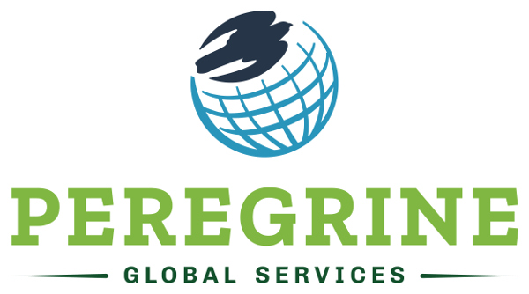

Client Services Manager
Do you want to make a difference in the world? Are you a professional looking for a challenging and inspiring career?
Peregrine Global Services, located in the Gillette, WY, has an opening on our client support team. In this role you would provide administrative and technical support for our academic clients, through professional communication and problem solving. Perform both reactive and proactive client support through report generation, data interpretation, webinars, and student technical support.
The ideal candidate will operate with integrity and confidentiality, take initiative with minimal guidance, and work cooperatively and collaboratively with other members of the team. Independent judgment is required to plan, prioritize, and organize a hectic and diversified workload. Attention to detail and the ability to understand and perform data analysis and basic statistics are essential.
A high school diploma or equivalent, plus 3-5 years’ experience in the client management field are required. Preference will be given to candidates with multilingual skills, advanced degrees, and previous experience working with institutions of higher education. Travel is expected and will be approximately 10-15% or 5-7 times per year. This position involves after-hours, on-call duties consisting of a one-week period, every 3-4 weeks (on-call is not a 24-hour service).
To apply, send a resume and cover letter to ramey@peregrineglobal.com or mail to PO Box 741 Gillette, WY 82717. Applications must be received by July 1, 2020.

