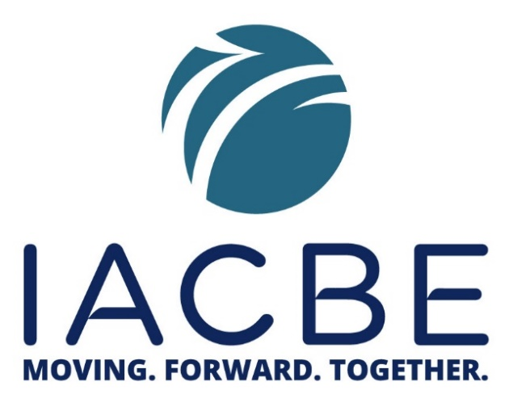
MOVING. FORWARD. TOGETHER. Sharing Your Victories and Challenges During COVID-19
The IACBE is sponsoring a weekly webinar to talk about how business faculty, staff, and administrators are dealing with the changes brought about by COVID-19, changes that we all face as we serve our students in a virtual world.
Topics for the April 23 webinar:
- What are micro-badges and is there a way to use them in our programs?
- How do I utilize engage my students in the virtual classroom without overwhelming them?
- If you could offer one piece of advice to your students and/or faculty as they navigate the “new normal” – what would that be?
- How does the move to virtual learning and working impact my IACBE accreditation?

Thursday, April 23, 2020
8:00-9:00 am EDT OR 12:00-1:00pm EDT
Cost: No Charge

To register for the 8:00 – 9:00 am (EDT) session go to
https://attendee.gotowebinar.com/register/6719907611975846413

To register for the 12:00 – 1:00 pm (EDT) session go to https://attendee.gotowebinar.com/register/560749137408081163

To view previous webinars go to https://www.gotostage.com/channel/96d73039be3e4b9cbae54c7e19524961

Links to future forums will be provided each week as we are MOVING. FORWARD. TOGETHER. through this challenging new environment for business programs.

