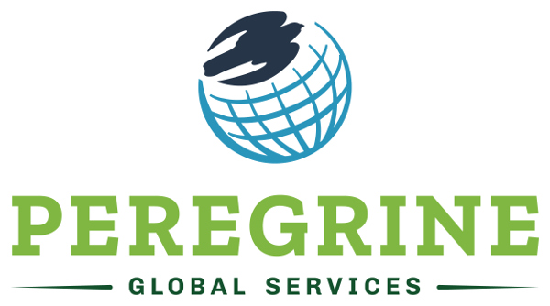

Accreditation Specialist
Under the general supervision of the Director of Client Services, acts as a champion for customer service and growth by providing administrative and technical support to developing relationships with academic institutions. Coordinates and manages accreditation consulting services and provides accreditation consulting to both current and prospective clients. Manages client communications and serving client needs. Performs both reactive and proactive client support through the development of communications, client check-ins, monitors quality control, and supports other departments of Peregrine Global Services as needed and working on special projects. If selected for the position, the person can either relocate to Gillette Wyoming or serve as a remote employee in a home office. For more information please contact Mr. Matt Ramey, CFO, at Peregrine Global Services by phone 307-685-1555 or by e-mail Ramey@PeregrineGlobal.com.

