IACBE Conference 2020: Presentation Scavenger Hunt

Those who choose to participate in the scavenger hunt will do the following:

1. There will be a slide in 21 of the presentations with the location and year of a past or future IACBE annual conference. Keep a note of the presentation title and which slide was shown. Be sure to note the location AND year as some locations have been visited more than once.
2. At the end of the conference, a survey quiz will be sent out for you to gather your answers!

* Complete the registration
* Complete the survey
* Submit the survey

1. Anyone who answers at least 50% correct will receive a set of Peregrine Global Services Bluetooth earbuds.

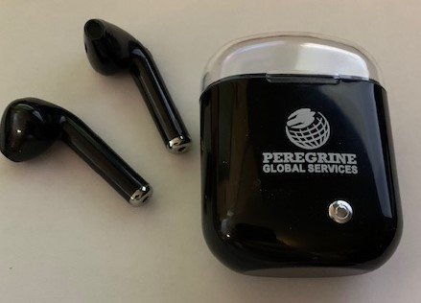

1. A $500 Amazon gift card will be given to the person who answers 100% correct. If more than one person gets 100%, there will be a drawing. If, by chance, no one received 100%, the winner will be the person with the highest percentage correct (or a drawing if this is tied).



1. Staff of Peregrine Global Services and IACBE are not eligible for the prize.