Credit Card Payment Information

Institution:
Invoice Number:
Send Payment Confirmation Email to:
Contact Phone:
Credit Card Type:
 | Visa
 | MasterCard
 | American Express
Amount to Charge to Card: |  |  |  |  | $ |  |  |  |  |  |  | + 3% convenience fee*
Name on Card:
Credit Card Number:
CVV Number*:
* For Visa and MasterCard, this is the 3-digit number on the back of your card adjacent to the signature strip on the right. For American Express, it is the 4-digit number on the front of your card above and to the right of your account number.
VISA/MASTERCARD |  |  |  |  |  |  |  |  |  |  | AMERICAN EXPRESS
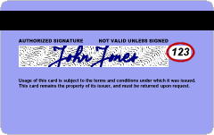 |  |  |  |  |  |  |  |  |  |  | 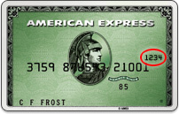
Expiration Date:
 |  |  | Month |  |  |  | Year
Billing Address:
City, State or Province, Zip or Postal Code:
Country:

*All credit card payments will incur a 3% convenience fee beginning January 1, 2019.

