

IACBE 2018 Great Lakes Regional Assembly

Conference Agenda

***Business Education: Learn. Apply. Experience.***

**Conference Hosts:**

**Spalding University**

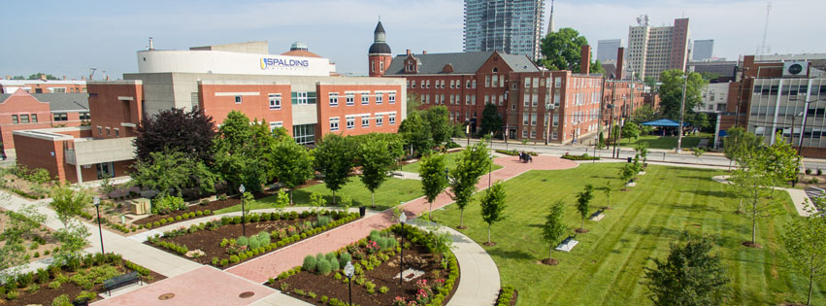



**SUMMARY**

IACBE 2018 Great Lakes Regional Assembly Conference Agenda

**Date: October 4-5, 2018**

**Location: Spalding University, Louisville, KY**

**Conference Hosts**: **Spalding School of Business**

**Conference Theme: Business Education: Learn. Apply. Experience.**

**Contact Persons**: **Dr. Robin Hinkle, Regional Vice President**

**Director, MS Business Communication**

**Spalding University**

**Louisville, KY 40203**

**502-873-4244**

[**rhin**](mailto:rhin)**kle@spalding.edu**

**LODGING**

***Please Note: Delegates are responsible for arranging their own transportation and lodging.***

**Special arrangements have been made for conference delegates at the following hotel:**

*The hotel is within walking distance to Spalding’s campus.*

**The Brown Hotel**

* A block of 10 rooms has been reserved for conference attendees from October 3-6.
* Room rate:  $179 per night (plus tax & fees) Note: Rooms and rates are guaranteed if booked by September 10, 2018.
* Location:  335 West Broadway, Louisville, KY 40202
* Phone:  502-583-1234
* Hotel website: <https://tinyurl.com/y8244h9v>

**AGENDA**

**Thursday | October 4, 2018**

**Conference**

**8:30 - 9:30 a.m. Registration and Breakfast**

Location: College Street Bldg, Caritas Room

**9:30 - 10:10 a.m.** *Service Learning & Peer Evaluation in a Finance Course*

**Dishant Pandya**

**Michelle Reiss, DBA**

**School of Business**

**Spalding University**

**Louisville, KY**

***10:10 - 10:20 a.m. Mid-morning break***

**10:20 - 11:00 a.m.** *Making the Most of the Internship Experience: More than Clocking Hours*

**Marjolijn van der Velde, Ph.D.**

**Donald W. Maine College of Business**

**Davenport University**

**Grand Rapids, Michigan**

***11:00 - 11:10 a.m. Late-morning break***

**11:10 – 11:50 a.m.** *I’m engaged! Maximizing the online learning experience.*

**JoAnna Williamson, Ph.D., J.D., MBA**

**Ross College of Business**

**Franklin University**

**Columbus, OH**

**12:00 - 1:30 p.m. Luncheon & Program - What are you serving as a Leader?**

**Guest Speaker – Dr. Hope Zoeller**

**1:40 – 2:20 p.m.** *Six Leadership Conversations that Matter: Powerful Questions to Build Community and Transform Your Organization*

**Donna M. Elkins, PhD**

**School of Communication**

**Spalding University**

**Louisville, KY**

**Thursday | October 4, 2018**

**Conference**

***2:20 – 2:30 p.m. Early-afternoon break***

**2:30 - 3:10 p.m.** *Using the IACBE Key Learning Outcomes to Improve Employability Skills*

**Dr. Phyllis Okrepkie, CMA**

**President**

**International Accreditation Council for Business Education**

***3:10 – 3:20 p.m. Mid-afternoon break***

**3:20 - 4:00 p.m.** *Student Perception of Classroom Engagement and Learning*

**Jim Gort, Ph.D.**

**Donald W. Maine College of Business**

**Davenport University**

**Grand Rapids, Michigan**

**5:00 p.m. Dinner with the Group**

**Friday |October 5, 2018**

**Conference**

**8:30 - 9:30 a.m. Registration and Breakfast**

Location: College Street Bldg, Caritas Room

**9:30 – 10:15 a.m. Business Meeting**

*Facilitated By: Dr. Wendell Seaborne, Regional President*

**IACBE Update** by Dr. Phyllis Okrepkie

***10:15 - 10:25 a.m. Mid-morning break***

**10:25 - 11:05 a.m.** *Team-Based Learning—Transforming Group Work into Team Work*

**Nancy Kern, EdD, MSN, APRN, FNP-C, AGNP-C**

**School of Nursing**

**Spalding University**

**Louisville, KY**

***11:05 - 11:15 a.m. Late-morning break***

**11:15 - 11:45 a.m. Student Team Case Study Presentation**

*Facilitated By:*

**11:15 – 11:55 a.m. Student Team Case Study Feedback with Judges**

*Student Team members and Coaches only*

*Facilitated By:*

**11:55 a.m. Closing Remarks**

**12:00 p.m. Adjourn**

**Box lunches are available if you need to travel or you may stay and join others for an informal lunch!**

