

**2018 IACBE Middle States Regional Assembly Conference**

**Conference Host:**

**MBA Program**

https://ci5.googleusercontent.com/proxy/Dab_QZ-4fu723_XEhnbvOECMrnDIazK2-sj7ooW9agI7atd-8rGAge8BbhvdfiBM-0iFPnugIjoy9-hbN7Cx12xnbN3zQ4qZhgrw=s0-d-e1-ft#http://www.umuc.edu/ui/images/signature/umuc-logo.jpg

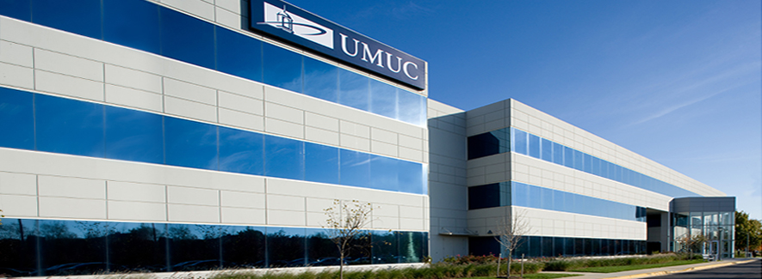

**2018 IACBE North Central Regional Assembly Conference**

**October 12, 2018**

**Location: University of Maryland University College**

**Academic Center, Largo, Maryland**

**1616 McCormick Drive**

**Largo, MD 20774**

**Contact Persons**:

**Rosemary Hartigan**

**Associate Vice Dean and Chair MBA**

**Business and Management**

**The Graduate School**

**University of Maryland University College**

**240-684-2484**

[**rosemary.hartigan@umuc.edu**](mailto:rosemary.hartigan@umuc.edu)

**Ravi Mittal**

**Chair MBA**

**Business and Management**

**The Graduate School**

**University of Maryland University College**

**240-684-2143**

[**ravi.mittal@umuc.edu**](mailto:ravi.mittal@umuc.edu)

***LODGING***

***Please Note: Delegates are responsible for arranging their own transportation and lodging.***

**Special arrangements have been made for conference delegates at**



*Holiday Inn Express & Suites Largo*

9101 Basil Ct, Largo, MD 20774

Phone: 301-636-6090 Ext: 518

Fax: 301-636-6091

E-mail: cweston@dhmhotels.com

* A block of 30 rooms has been reserved for conference attendees for October 11-12, 2018
* Room rate:  $119.00 per night (plus tax & fees)

The hotel is within short walking distance of the Academic Center in Largo and offers

* 89 guest rooms, including Deluxe King with pullout sofas, 40 Double Queen Executive rooms and 18 Suites overlooking landscaped courtyard.
* ***Complimentary High Speed Internet Access*** in all Guestrooms and Meeting Space
* ***Complimentary Shuttle Service*** within a 5 mile radius of the Hotel
* ***Complimentary Breakfast*** featuring Hot/Cold items Monday-Sunday 6:30am – 10:00am
* On Site Business Center
* On Site Fitness Center
* ***Complimentary Parking***
* On-Site Guest Laundry Facility
* Refrigerator, Microwave, Irons & Ironing Boards, and Coffee Makers available in each guestroom

**To register use:**

**Block Code: IAC**

**Block Link:**

[**https://www.hiexpress.com/redirect?path=event-facilities&brandCode=EX&localeCode=en&regionCode=1&hotelCode=lnhmd&_PMID=99801505&GPC=IAC&viewfullsite=true**](https://www.hiexpress.com/redirect?path=event-facilities&brandCode=EX&localeCode=en&regionCode=1&hotelCode=lnhmd&_PMID=99801505&GPC=IAC&viewfullsite=true)

**Other hotel options within walking distance**

**Doubletree by Hilton**

**9100 Basil Court, Largo, MD 20744**

**301-773-0700**

[**www.doubletreelargo.com**](http://www.doubletreelargo.com)

**Courtyard Largo Capital Beltway**

**1320 Carraway Court, Largo MD 20744**

**302-925-1400**

**www.marriott.com/hotels/travel/waspg-courtyard-largo-capital-beltway/**