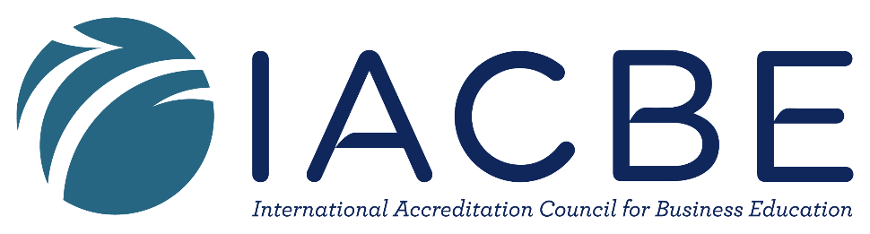

IACBE Northwest Regional Assembly Conference

Theme: Give them some R & R: Make it Real & Relevant
Call for Presentation Proposals

October 19th, 2018

Location: North Idaho College |Coeur d’Alene Idaho

Conference Hosts: Lewis-Clark State College

The hosts of the IACBE Region 7 conference are requesting proposals for 30 minute presentations relating to this year’s conference theme—Make is Real and Relevant.

Possible presentation topics could address, but are not limited, to the following areas:

- Connecting learning to life
- Service based learning
- Experiential Learning
- Using live cases
- The value of case studies
- Incorporating Guest speakers
- Making online course “real”

Proposal Submission Guidelines
- All proposals for conference presentations must include the following elements:
  - The name(s) and affiliation(s) of presenters
  - Title of the presentation
  - A 150 word abstract of the presentation
  - Fully developed summary of the presentation (3 to 5 pages)
  - Audio-visual technology needs
- Presentations designed for 30 minutes, including time for questions and answers.
- Submission deadline: August 25th, 2018
- Acceptance confirmation: September 15th, 2016

Contact Persons: Luther Maddy, Ph.D.
Associate Professor
Business Division
Lewis-Clark State College
208-792-2702
Lmmaddy@lcsc.edu

