IACBE Great Lakes Region Assembly Conference
October 4 & 5, 2018
Spalding University
Louisville, KY
Proposal Deadline: July 16, 2018
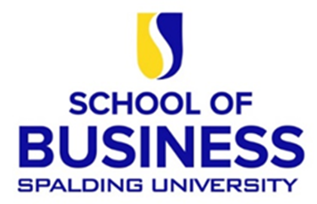

Call For Presentations

IACBE
Business Education: Learn. Apply. Experience.

- Leadership Skills
- Communications Skills
- Problem Identification and Solving
- Analytical Skills
- Project Management Skills
- Topics in Marketing
- Teamwork Skills and Intercultural Management
- Examples of experiential learning or application of business education in the real world
- Other Topics Related to Business Education

Conference Theme

Great Lakes
This is your invite to the existing property commercial development and future development sites seminar. This helpful information is for you. Please, don’t wait, call to book reservations now.

International Accreditation Council for Business Education (IACBE)
Great Lakes Regional Assembly Conference

October, 4 & 5, 2018
Call for Proposals & Submission Form
Deadline for Submissions: July 16, 2018

Theme: Business Education: Learn. Apply. Experience.

Theme:

This Call for Proposals seeks contributors who are interested in conducting presentations, workshops, or discussion forums that align with the conference theme. Preference will be given to submissions that appeal to the target audience of our attendees and offer practicable solutions or approaches.

Submissions that are not strictly concerned with the area of business education but enhance the knowledge base of our constituents and provide opportunities for idea sharing, will also be considered.

Submissions that are received by the deadline of July 16, 2018 will be peer-reviewed immediately and selectees will be notified of the acceptance decision. Submissions received after the deadline will also be reviewed and accepted on a rolling basis depending upon both applicability and availability.

Title of Session:

Please provide the title for your session as you would like it to appear in the conference program.

Type of Session:

Please briefly identify the type of session that you are proposing and a short abstract.

The time allotted for each session is 40 minutes and includes questions and answers from the audience.

Names of Submitters and Primary Contact:

Include full names and titles of each submitter as you would like them to appear on the program. Identify the primary contact and include the following information for this individual as well as for each of the other submitters as applicable.

Institution(s):

E-mail Address(es):

Telephone:

All proposals and CVs/Résumés of presenters must be submitted via email and must be received by July 16, 2018. Please email your proposal to: rhinkle@spalding.edu. A rolling acceptance process will allow a quick decision on the submitted abstract proposal.

Note: All presenters must be registered for the conference. Proposals submitted after the deadline will be considered on a space-available basis only.

