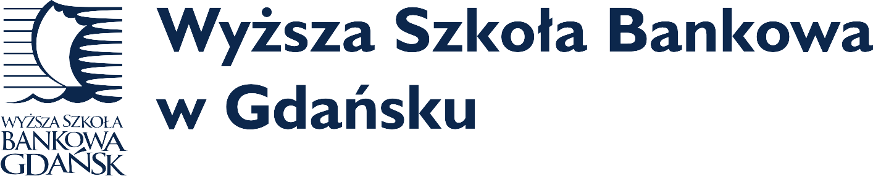
IACBE European Region 9 Assembly Conference
October 10, 11, 12, 2018
WSB University in Gdansk
Gdansk, Poland
Proposal Deadline: July 15, 2018

Call For Presentations

IACBE
New Tech Revolution and its Impact on Higher Education
- Trends in Business Education
- Strategies for Innovative Teaching & Learning
- Maintaining High Impact Programs
- Technology in the Classroom
- Distant/E-Learning
- Apprenticeships, Internships, Practicums
- New Developments in Cross-border Education
- Open Topics Related to Business Education

Conference Theme

European Region
This is your invite to the existing property commercial development and future development sites seminar. This helpful information is for you. Please, don’t wait, call to book reservations now.

International Accreditation Council for Business Education (IACBE)
European Regional Assembly Conference

October, 10, 11, 12, 2018
Venue: Radosson Blu Hotel, Gdansk, Dlugi Targ 19
Call for Proposals & Submission Form
Deadline for Submissions: July 15, 2018

Theme: New Tech Revolution and its Impact on Higher Education

Theme:

This Call for Proposals seeks contributors who are interested in conducting presentations, or workshops that match the conference theme. Preference will be given to submissions that appeal to the target audience of our attendees and offer practicable solutions, idea-sharing or approaches.

Submissions that are not strictly concerned with the area of the future of business education but also those which enhance the knowledge base of our constituents, will be considered as well.

Submissions that are received by the deadline of July 15th will be peer-reviewed immediately and selectees will be notified of the acceptance decision. Submissions received after the deadline will also be reviewed and accepted on a rolling basis depending upon both applicability and availability.

Title of Session:

Please provide the title for your session as you would like it to appear in the conference program.

Type of Session:

Please briefly identify the type of session that you are proposing and a short abstract.

Please plan to present for approximately 20 minutes and to allow 10 minutes for questions and answers from the audience.
Names of Submitters and Primary Contact:

Include full names and titles of each submitter as you would like them to appear on the program. Identify the primary contact and include the following information for this individual as well as for each of the other submitters as applicable.

Institution(s):

E-mail Address(es):

Telephone:

All proposals and CVs/Résumés of presenters must be submitted via email and must be received by July 15, 2018. Please email your proposal to: iacbe@wsb.gda.pl. A rolling acceptance process will allow a quick decision on the submitted abstract proposal.

Note: All presenters must be registered for the conference. Proposals submitted after the deadline will be considered on a space-available basis only.

